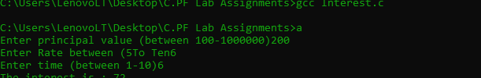

#include<stdio.h>

int main()

{

int _P,_T,_SI;

int _R;

printf("Enter principal value (between 100-1000000)");

scanf("%d",&_P);

printf("Enter Rate between (5%To Ten%");

scanf("%d",&_R);

printf("Enter time (between 1-10)");

scanf("%d",&_T);

_SI = (_P*_R*_T)/100 ;

printf("The interest is : %d",_SI);

return 0 ;

}